YARD DUTY AND SUPERVISION POLICY

# PURPOSE

To ensure school staff understand their supervision and yard duty responsibilities.

# SCOPE

Kingswood’s first value is, ‘We are here for the students,’ and, as such, our priority is the safety and care of the students enrolled. The principal is responsible for ensuring that there is a well-organised and responsive system of supervision in place during school hours, before and after school, and on school excursions and camps.

This policy applies to all teaching and non-teaching staff at Kingswood Primary School, including education support staff, casual relief teachers and visiting teachers.

School staff are responsible for following reasonable and lawful instructions from the principal, including instructions to provide supervision to students at specific dates, time and places.

# POLICY

**Before and after school**

Kingswood Primary School’s grounds are supervised by school staff from 8:45am until 3:45pm. Outside of these hours, school staff will not be available to supervise students. Parents are regularly reminded through the school newsletter, Compass posts, etc. that they should not leave their children unsupervised on the school grounds outside of these times.

If a student arrives at school before supervision commences at the beginning of the day, the principal or nominee staff member will, as soon as practicable, follow up with the parent/carer to:

* advise of the supervision arrangements before school
* request that the parent/ carer make alternate arrangements
* escort the child to the Outside School Hours Care provider. Parents will be liable for costs associated with this service.

If a student is not collected before supervision finishes at the end of the day, the principal or nominee staff member will consider whether it is appropriate to:

* attempt to contact the parents/carers
* attempt to contact the emergency contacts
* escort the child to the Outside School Hours Care provider. Parents will be liable for costs associated with this service.
* contact Victoria Police and/or the Department of Health and Human Services (Child Protection) to arrange for the supervision, care and protection of the student.

School staff who are rostered on for before, during or after school supervision must follow the processes outlined below.

**Yard duty**

All teaching staff and integration aides at Kingswood Primary School are expected to assist with yard duty supervision and will be included in the weekly roster.

The assistant principal is responsible for preparing and communicating the yard duty roster on a regular basis. At Kingswood Primary school, staff will be designated a specific yard duty area to supervise.

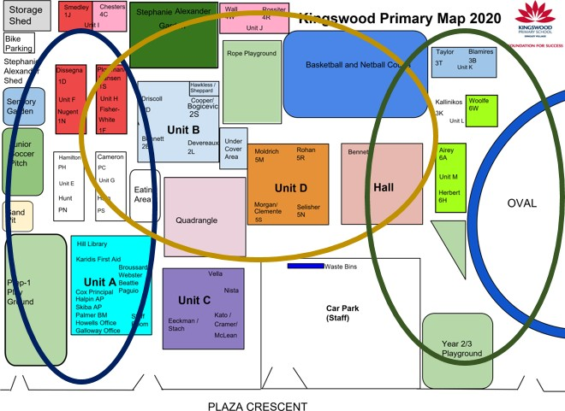

The designated yard duty areas for our school (as at Term 1, 2021) are illustrated in the map above.

Teachers on duty must wear a provided hi-vis vest whilst on yard duty and carry a basic first aid pack with them. These will be stored in Sick Bay. Teachers must also carry a mobile communication device while on duty that they can use to contact the office in an emergency.

Teachers who are rostered for yard duty must remain in the designated area until they are replaced by a relieving teacher.

2

During yard duty, supervising staff must:

* methodically move around the designated zone
* be alert and vigilant
* intervene immediately if potentially dangerous or inappropriate behaviour is observed in the yard
* enforce behavioural standards and implement appropriate consequences for breaches of safety rules, in accordance with relevant disciplinary measures set out in our [*Student Engagement and Wellbeing*](http://kingswood.vic.edu.au/assets/uploads/2019/08/Student-Engagement-Wellbeing.pdf)[policy](http://kingswood.vic.edu.au/assets/uploads/2019/08/Student-Engagement-Wellbeing.pdf)
* ensure that students who require first aid assistance receive it as soon as practicable – this may be directly by the teacher on the yard or by the First Aid Officer
* log any incidents or near misses on the Kingswood Yard Duty Google Form

If being relieved of their yard duty shift by another staff member, ensure that a brief but adequate verbal ‘handover’ is given to the next staff member in relation to any issues which may have arisen during the first shift.

If the supervising staff member is unable to conduct yard duty at the designated time, they should make arrangements to swap their duty with another staff member. All swaps must be logged on the Daily Bulletin on Compass. On occasions where a staff member cannot make arrangements to swap their yard duty, they should contact the assistant principal with as much notice as possible prior to the relevant yard duty shift to ensure that alternative arrangements are made.

If the supervising teacher needs to leave yard duty during the allocated time, they should contact the assistant principal but should not leave the designated area until the relieving teacher has arrived in the designated area.

If a relieving or next teacher does not arrive for yard duty, the teacher currently on duty should contact the school office by phone and not leave the designated area until a replacement staff member has arrived.

Should students require assistance during recess or lunchtime, they are encouraged to speak to the supervising yard duty staff member.

# FURTHER INFORMATION AND RESOURCES

* School Policy and Advisory Guide:
  + [Supervision](http://www.education.vic.gov.au/school/principals/spag/safety/pages/supervision.aspx)
  + [Duty of Care](http://www.education.vic.gov.au/school/principals/spag/safety/Pages/dutyofcare.aspx)
  + [Child Safe Standards](http://www.education.vic.gov.au/school/principals/spag/safety/Pages/childsafestandards.aspx)
  + [Visitors in Schools](http://www.education.vic.gov.au/school/principals/spag/safety/Pages/visitorsinschool.aspx)

**REVIEW CYCLE**

This policy was last updated in May 2021 and is scheduled for review in May 2022. This policy will also be updated if significant changes are made to school grounds that require a revision of Kingswood Primary School’s yard duty and supervision arrangements.

**Kingswood Primary School** Plaza Crescent Dingley Village 3172

**Email** [kingswood.ps@edumail.vic.gov.au](mailto:kingswood.ps@edumail.vic.gov.au) **Website** kingswood.vic.edu.au 3

**Phone** 03 9551 1727 **Facsimile** 9551 4544