Sprouts

Sprouting is an easy, quick, and fun way of converting seeds into edible, nutrient-dense plants called ‘sprouts’. Moong/mung bean sprouts are a yummy way to add more protein, iron, potassium, and Vitamin A, C, and E into the diet. Simply follow the instructions below and let the fun of growing and eating your own sprouts begin!





How to Sprout

**Things you will need:**

* A clean empty container. Such as a jar or plastic water bottle with the lid cut off.
* Moong/mung beans. *Available in speciality supermarkets and grocery stores. Such as Spices and Saree Bazaar, 1/16 Station Street, Cheltenham.*
* Cheese cloth or glad wrap
* Rubber band
* Water

**Sprouting Instructions:**

1. Place Moong beans into container.

2. Cover Moong beans with water. Ensure that the water level is 2-3 times higher than the level of the Moong beans.

3. Cover the top of the container with cheese cloth/glad wrap and secure with rubber band. If using glad wrap, make a few small holes to allow fresh air into the container.

4. Leave Moong beans to soak for 24 hours.

5. Make sure you are at a sink or outside and that the top of the container is secure. Drain Moong beans by turning the container upside down and shaking, gently.

6. Rinse Moong beans with fresh water and drain again (See Step 5.)

7. Leave for 24 hours.

8. Continue to rinse and drain Moong beans (See step 5. and 6.) daily until the sprouts are ready to eat. This will take approximately 3 days in warmer weather and 5-7 days in colder weather.

9. Gently rub sprouts to remove the green outer layer and store in the fridge.

* Go to [www.sproutpeople.org](http://www.sproutpeople.org) for more information about sprouts. Including recipes and the many different types of seeds that can be used for sprouting.

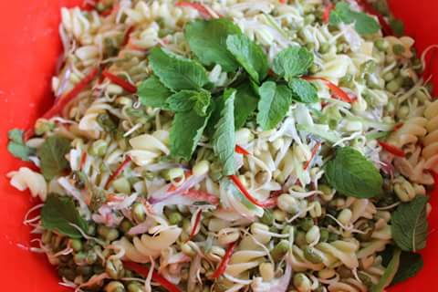

Eating Sprouts

Sprouts can be enjoyed in different ways. Such as:

* On their own as a crunchy snack
* Added to
* Sandwiches
* Omelettes
* Salads
* Stir fries
* Pasta
* Curries
* Pizza
* Soups



