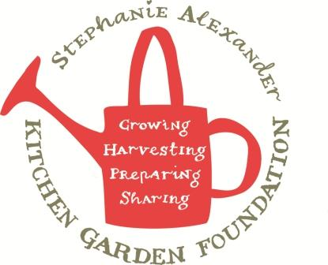

Ratatouille

Season: Autumn
Type: Side dish
Source: adapted from taste.com.au
Difficulty: Easy
Serves: 35 tastes
Fresh from the garden: eggplant, green capsisum, zucchini, green beans, cherry tomatoes (preserved in jar)
Equipment:  Chopping board  Chef’s knife  Large frying pan  Wooden spoon  measuring spoons  scales | - Ingredients  - 1 tbs Olive oil  - 3 tbs salt  - 2 eggplant (600g)  - 5 zucchini (750g)  - 2 green capsisums  - 2 brown onions  - 2 cloves garlic  - 1 jar cherry tomatoes (approx. 700g)  - ½ jar passata (350g)  - 2 tbs tomato paste  - 200g green beans  - ½ cup shredded basil

What to do:
- Cut eggplant into 1 cm slices, place in the sink in a colander. Sprinkle with salt. Place a small plate on top and leave for 20 minutes.
- Finely chop onions and garlic. Chop green capsicum into small cubes.
- Heat oil in a large frying pan, cook onion, capsicum and garlic for 5 minutes.
- Chop zucchini into small cubes.
- Rinse and pat dry eggplants then cut into small cubes.
- Add zucchini and eggplant to frying pan, cook for 5 mins.
- Add jar of tomatoes and tomato paste, reduce heat to low and simmer for 15 mins.
- Cut ends off beans then slice beans into 2 cm pieces, add to frying pan and cook for 5 minutes.
- Chop basil and stir through ratatouille, season with salt and pepper.

