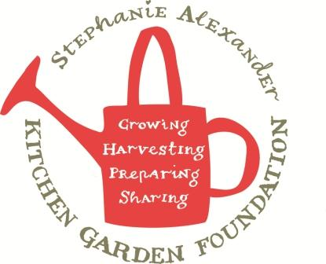

Potato & Carrot Hash Browns

Season: Any
Type: Side dish
Source: adapted from taste.com.au
Difficulty: Easy
Serves: 25-30 hash browns
Fresh from the garden: potato, carrots and eggs

Equipment:  Chopping board  Peelers  Graters  Large mixing bowl  whisk  Wooden spoon  ¼ cup measuring cup  Frying pans x 2  Spatular  Oven dish  Paper towel | - Ingredients:  - 1 kg potatoes  - 750g carrots  - 3 eggs  - ½ cup plain flour  - salt and pepper  - Vegetable oil

What to do:
- Preheat oven to 180 degrees celsius.
- Peel and grate carrots and potatoes into separate bowls.
- Place grated potatoes onto a tea towel. Squeeze out any excess water.
- Lightly whisk eggs in large mixing bowl. Add flour, potato and carrots.
- Fill frying pan to 0.5cm high with oil for shallow frying, heat oil.
- Measure ¼ cups of mixture into hot oil. Turn when golden.
- Place hash browns on paper towel in oven dish and keep warm in oven.

