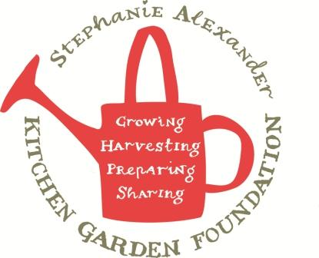

Potato Gnocchi

Season: Any
Type: Main or entree
Difficulty: Medium
Serves: 20 tastes
From the garden: eggs Source: Taste.com.au
Dietary considerations: contains egg, dairy and wheat

Equipment:  Peeler  Chopping board  Chef’s knife  Steamer  Potato Masher  Wooden spoon  Small bowl  Fork  Large saucepan | Ingredients:  1.6 kg Potato  2 Eggs  4 cups plain flour  1/2 cup parmesan cheese  plain flour to dust

What to do:
- Add enough water to a saucepan to reach a depth of 3cm. Bring to the boil.
- Peel and chop potatoes into quarters, place in a metal steaming basket.
- Place steamer in saucepan making sure steamer does not touch the water. Steam for 15-20 minutes or until potatoes are tender. Transfer to a bowl and leave to cool.

- Meanwhile, take the cooled potatoes from the previous class and mash with a potato masher, season with salt and pepper.
- Lightly beat the egg with a fork and add to the potato, stir with a wooden spoon.
- Add half the flour and the Parmesan cheese and stir until combined. Add remaining flour, in two more batches until well combined and a firm dough forms.
- Turn out onto a lightly floured surface and knead until smooth.
- Line a baking tray with non-stick paper.
- Divide mixture into 8 portions. Roll 1 portion into a sausage about 30cm long.
- Use a lightly floured knife to cut into 2cm pieces. Repeat with remaining dough.
- Lightly flour the gnocchi and roll down the prongs of a fork to create a pattern.
- Bring a large saucepan of water to the boil over medium heat. Add one-quarter of the gnocchi (in a single layer, do not overcrowd the gnocchi. Cook for 3 minutes or until they rise to the top. Use a slotted spoon to drain the gnocchi then place in a oven dish and cover to keep warm. Repeat with remaining gnocchi.

