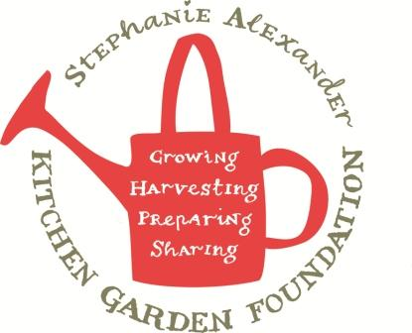

Pad Pak

Season: Any
Type: Side dish
Difficulty: Easy
Serves: 35 tastes
Fresh from the garden: pak choy, basil
Equipment:  Chopping board  Chef’s knife  Wok  Wooden spoon  measuring spoons | Ingredients  - 4 tablespoons oyster sauce  - 2 teaspoon palm sugar or brown sugar  - 1 tablespoon sesame oil  - 4 tbs sunflower oil  - 1 bunch spring onions, cut into 5cm lengths  - 2 bunches pak choy, sliced  - 2 bunches broccolini, sliced diagonally  - 2 cups Thai basil or basil leaves

What to do:
- To make the dressing, combine oyster sauce, sugar, sesame oil and 2 tablespoons sunflower oil in a small bowl. Set aside.
- Chop spring onions into 5 cm lengths.
- Separate stems and leaves of pak choy and finely slice each and place in separate bowls.
- Slice broccolini on the diagonal and place in bowl with pak choy stems.
- Heat remaining 2 tablespoons oil in a frypan over medium heat. Stir-fry spring onion for 2 minutes or until just wilted.
- Add pak choy stems and broccolini, stir fry for 2 minutes.
- Add pak choy leaves and basil and stir-fry for 1-2 minutes until tender.
- Pour dressing over vegetables and stir through.

