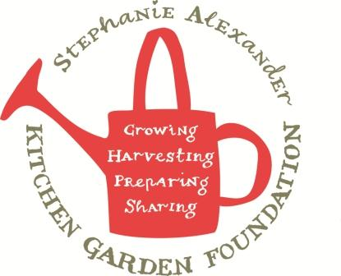

Nut-free Spinach Basil Pesto

Season: Summer
Type: Accompaniment
Difficulty: Easy
Serves: 1 cup
From the garden: spinach , lemons Source: twopeasandtheirpod.com
Dietary considerations: sauce contains dairy.

Equipment:  Blender  Salad spinner  Chef’s knife  Chopping board  Juicer  Measuring jug | Ingredients:  4 cups spinach  2 cups basil  1 clove garlic  1 tablespoon lemon juice  ¼ cup Parmesan cheese  ½ teaspoon salt  ½ teaspoon pepper  ¼ cup olive oil

What to do:
- Wash spinach and basil thoroughly. Dry in the salad spinner.
- Crush garlic with the flat side of a knife then roughly chop.
- Juice lemon.
- Grate Parmesan cheese.
- Place spinach, basil, garlic, lemon juice, Parmesan cheese, salt and pepper in blender.
- While blending, slowly pour in olive oil and process until smooth.
- Store in a jar in fridge for 2 weeks or you can freeze.

