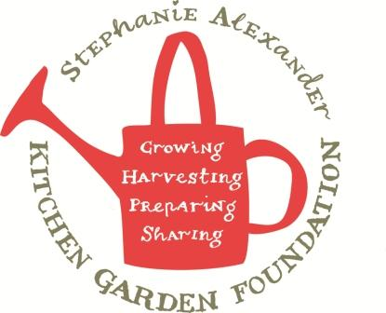

Cauliflower and Potato Soup

Season: Winter
Type: Soup
Difficulty: Easy
Serves: 20 tastes
Fresh from the garden: cauliflower, potatoes, leek
Source: adapted from taste.com.au
Dietary considerations: leave out bacon & cream for those who don’t eat pork or dairy.

Equipment:  Chopping board  Chef’s Knife  Peeler  Measuring spoons  Measuring jug  Large stock Pot  Small frying pan  Stick Blender  Soup ladle | Ingredients:  - 1 tablespoon olive oil  - 2 garlic cloves, crushed  - 2 leeks, halved, washed, thinly sliced  - ½ cauliflower, trimmed, cut into small florets  - 500g Sebago or Desiree potatoes, peeled, diced  - 6 cups vegetable stock  - 250g bacon, finely chopped  - 1/4 cup light thickened cream

What to do:
- Peel and cut potatoes into 2cm cubes.
- Chop garlic and leek.
- Heat 2 teaspoons oil in large stock pot. Fry garlic and leek, over medium heat for 5 minutes.
- Add potato and stock. Partially cover. Increase heat to medium-high and bring to the boil. Reduce heat to low and simmer, stirring occasionally, for 15 minutes.
- Add cauliflower and cook for a further 10minutes or until vegetables are tender.
- Meanwhile, finely chop bacon, then heat 2 teaspoons oil in a small frying pan over medium-high heat. Add bacon and cook, stirring often, for 3 minutes or until crisp. Remove to a plate lined with paper towel.
- Blend soup, in batches, until smooth. Check for people with allergies or who don’t eat pork and then stir in cream. Taste and then season with salt and pepper
- Ladle into bowls. Sprinkle with bacon and freshly ground pepper.

