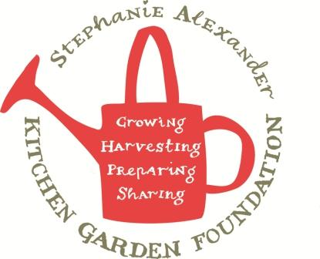

Bubble and Squeak

Season: Winter
Type: Main/Accompaniment
Difficulty: Easy
Serves: 12 tastes
Fresh from the garden: cabbage, spring onion

Equipment:  Chopping board  Chef’s Knife  Peeler  Large Frying pan  Large saucepan  Potato masher  Wooden spoon  Egg slide | Ingredients:  - 1 tablespoon olive oil  - 5 medium potatoes (750g)  - 2 carrots (250g)  - 1/8 cabbage (300g)  - 1 onion  - 2 spring onions  - salt and pepper

What to do:
- Finely dice carrots.
- Finely shred cabbage.
- Finely chop onions.
- Finely slice spring onions.
- In a large frying pan heat 2 teaspoons of oil and sauté onions for 5 minutes until soft.
- Add carrots and cabbage, continue to fry for 3-4 minutes until carrots are tender.
- Add spring onions and fry for a minute.
- Mash the potatoes and then stir the vegetable mixture into the mashed potato.
- Season with salt and pepper.
- Heat remaining 2 teaspoons of oil in large frying pan, add potato mixture, spread out like a pancake. Leave to cook for about 20 minutes or until base is brown.
- Peel potatoes and leave whole.
- Place potatoes into a large pot of cold water and bring to the boil. Cook for 20 minutes or until potatoes are tender. Drain potatoes and leave in saucepan for next class.
- Transfer bubble and squeak to griller to brown top.
- Slice into12 pieces, serve.

